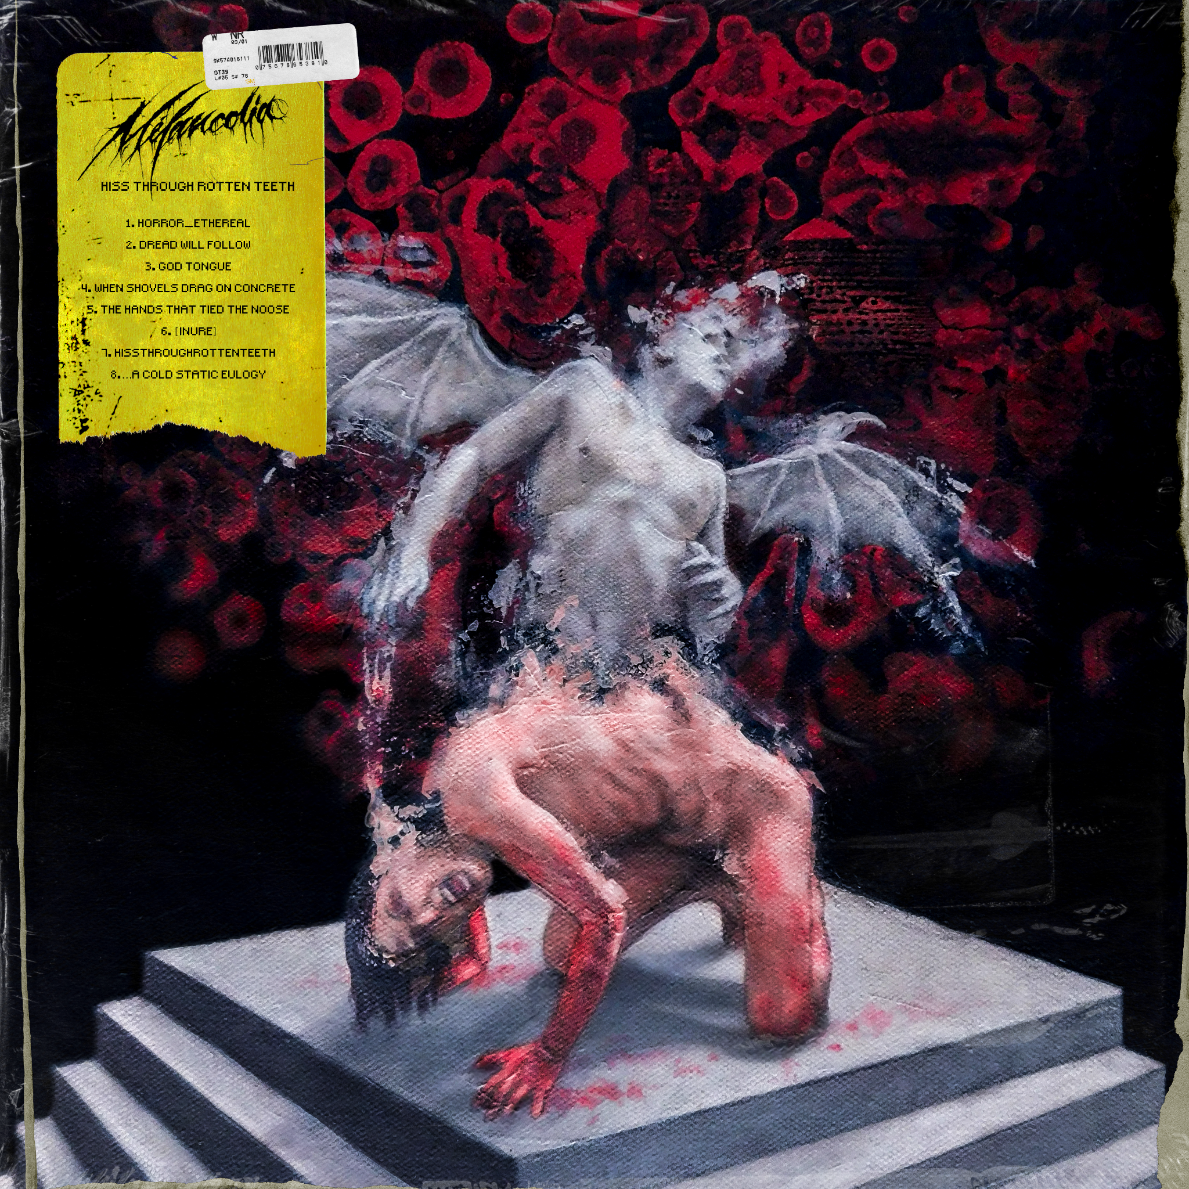

MÉLANCOLIA
HISSTHROUGHROTTENTEETH

Release Date: April 21st

Line up: | MÉLANCOLIA online:
Alex Hill - Vocals  Joshua Taafe - Guitar  Billy Morris - Guitar  Mason Page - Drums | https://www.facebook.com/melancolia.aus/  https://twitter.com/melancolia_exe  https://www.instagram.com/melancolia_exe/  https://www.youtube.com/@melancolia_exe

From under the veil of obscurity emerges MÉLANCOLIA a tormented entity trapped within the claws of despair, angst, and unnerving melancholy. Like messengers of darkness, Alex Hill takes his place at the forefront as vocalist, Joshua Taafe and Billy Morris join the fold as guitarists with Mason Page on drums. Launching in 2022, Mélancolia is melodic blackened deathcore that melds elements from the depths of industrial goth and nü-metal with its pummeling foundations, resulting in what can only be described as sonic horror.

Unleashed last February, “Horror_Ethereal” is MÉLANCOLIA’s debut offering, introducing nightmarish settings, Cradle Of Filth-inspired fits, and harrowing visuals. Releasing independently, the single has collected tens of thousands of digital streams under their own steam. Wall Of Sound concluded: “With blackened deathcore blast-beats, retching high vocals, and theatrical sonic breakdowns, this band is going to be one to watch, seriously.”

MÉLANCOLIA storm through the gates of 2023 with a vengeance, playing their first-ever show with labelmates THY ART IS MURDER on their ‘Decade Of Hate’ Australian Tour in January alongside Starve and Justice For The Damned. As a sign of what's to come, the band looks towards a future equipped with heavyweight reinforcements as they join the Greyscale Records in Australia and New Zealand and Nuclear Blast for the rest of the world and fly under the wing of Future History Management (Sleep Token, Loathe).

With album news, the quartet announces their story unravels with, HISSTHROUGHROTTENTEETH, MÉLANCOLIA’s debut album out April 21st, 2023 via Greyscale Records and Nuclear Blast. Immersing listeners in a torturous tale of birth, life, and death, HISSTHROUGHROTTENTEETH follows a fallen deity, cast down from a godly realm and met with the punishment of reincarnating as a human with a wealth of knowledge yet stripped entirely of power. The album traverses different stages of the deity’s miserable existence, doomed to repeat a painful cycle for all of eternity. MÉLANCOLIA sink their teeth into their monstrous storyline with eerie passages, guttural deliveries, and grotesque visuals, serving up a delicate dose of pure dread.

